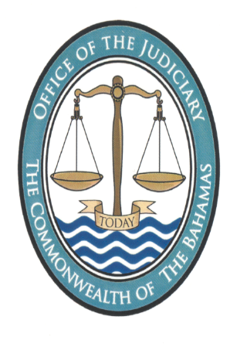
NOTICE
Pursuant to section 8 of the Juries (Amendment) Act, 2014, the Revising Panel shall sit to hear objections to the 2024 Jury List on 4th December 2023 from 10:00 am to 1:00 p.m., and from 3:00 p.m. to 6:00 p.m. on the said date at the Supreme Court Garnet Levarity Justice Centre, Freeport Grand Bahama.
A hard copy of the proposed 2024 Jury List together with this accompanying Notice is available for inspection by any member of the public during weekdays between the hours of 9:30 am to 4:30 pm at the ground floor at the Supreme Court Garnet Levarity Justice Centre, Freeport Grand Bahama. In addition, the said Jury List will also be available on the Judiciary’s website at www.bahamasjudiciary.com

Registrar
The Supreme Court
15th November 2023

